Multi-Factor Authentication (MFA)
1-Page Summary Report • Pure-Python TOTP + Lockout + Simulation

Problem Statement
After users can generate strong passwords, the next security layer is Multi-Factor Authentication. The task is to implement a complete, standards-based MFA system in pure Python (stdlib only) that combines: (1) salted PBKDF2 password hashing, (2) RFC 6238 TOTP (HMAC-SHA1, 30-second steps), (3) single-use backup codes, and (4) automatic account lockout after repeated failures. A Monte-Carlo simulation must quantify how OTP window size and guess volume affect brute-force success probability.

Solution Strategy
- Password layer: PBKDF2-HMAC-SHA256 (100 k iterations) with per-user random salt and constant-time comparison.
- OTP layer: pure HOTP → TOTP implementation; verification accepts a configurable ±window of time steps.
- Recovery: 8 one-time backup codes (unambiguous alphabet) stored with the user record.
- Hardening: failed-attempt counter + temporary lockout; optional rate-limit helper.

Solution
Core artefacts: UserStore class (register / authenticate), generate_totp_secret, totp / verify_totp, generate_backup_codes. Alternate pure-functional dictionary style also supplied. Demo flow registers “alice”, prints the base32 secret and current 6-digit code, then succeeds on both TOTP and backup-code paths.
Simulation (N=400) shows that even with a ±1 window an attacker needs hundreds of guesses per 30-second step to reach non-negligible success probability; effective security remains ~18–19 bits. Larger windows trade usability for a linear drop in security.
Security Simulation Charts
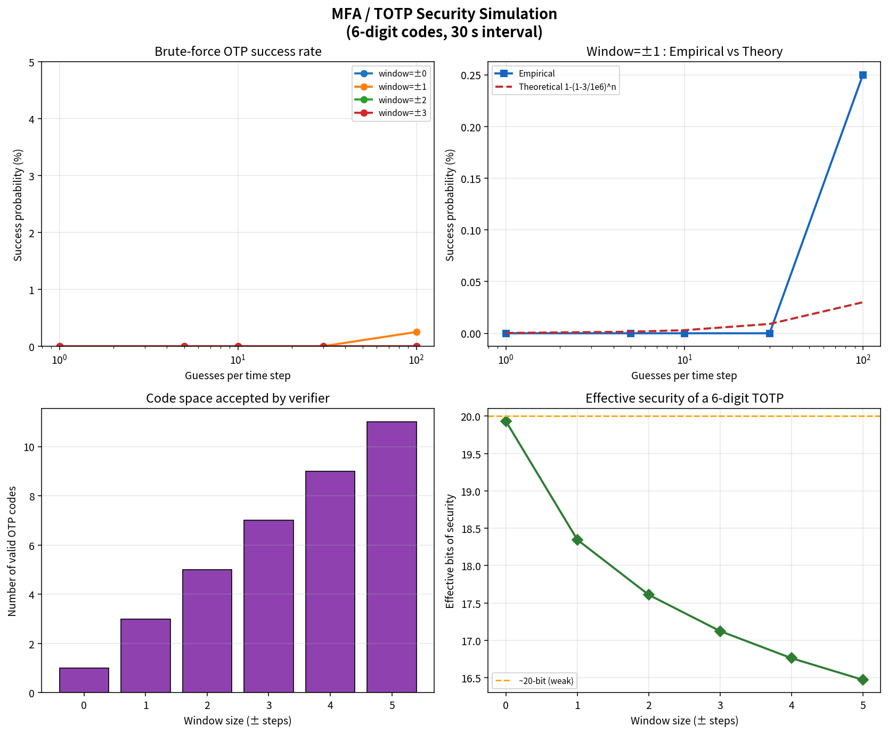

Key Takeaways
- MFA multiplies the difficulty of account takeover: an attacker must compromise both the password and a second factor that changes every 30 s.
- Implement TOTP yourself (HMAC-SHA1 + truncate) to understand exactly what authenticator apps are computing.
- Always pair OTP verification with lockout / rate-limiting; otherwise the 6-digit space can be searched online.
- Backup codes are a necessary recovery path but must be single-use and treated as secrets.
- Deliverables: Practice Skeleton + Solution notebooks, flowchart, simulation chart, standalone .py module, this report.

